**Experiment-4**

**DESIGN A PUSH BUTTON SWITCH INTERFACE -DOOR BELL CONTROL**

**Circuit Diagram**

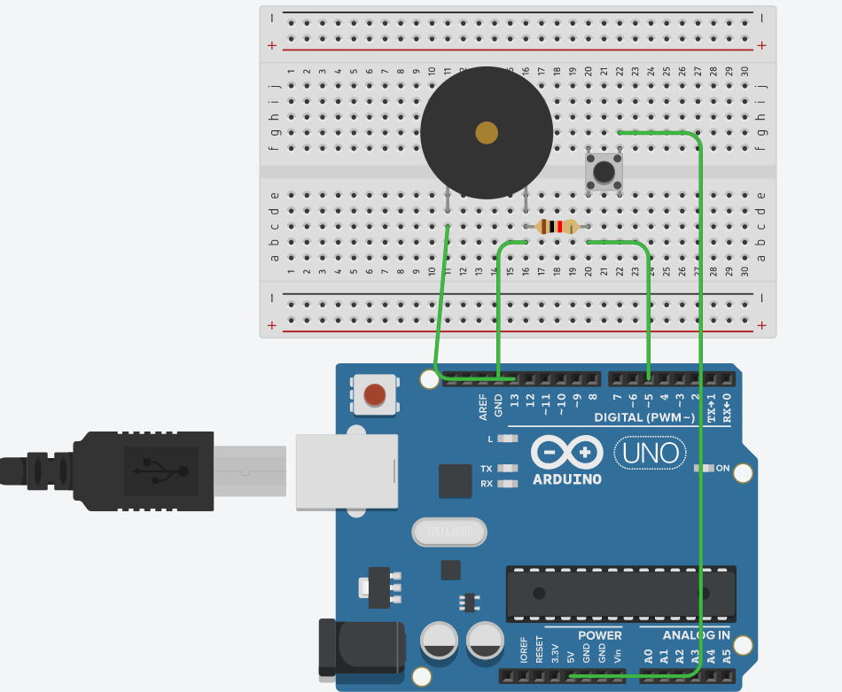

**Theory:**

**Concept Used:**

The concepts used for realization and implementation of the task are:

* The arduino board supply a power of 5V which we call as HIGH and 0V which we call as LOW digital output signals through the 14 pins present on the Arduino board

* The GND pin on Arduino board is ground.
* And the concept of breadboard where there are two rows each on top and bottom of it, connected to each other.
* Concept of push button and the buzzer so that everytime button is pressed buzzer makes a sound.

**Learning and Observation:**

**Learning:**

* With the help of this experiment I got to know about the concept of door bell and how with the help of connections on Arduino and breadboard buzzer can be made to work using press button.

**Observations:**

I observed that after completing connections

Of push button and buzzer on breadboard

and uploading the required code the buzzer starts making sound when the button is pressed.

**Problems and Troubleshooting:**

* The circuit was not getting closed because some wires used were short and not at place so I tried to change the position.
* The Arduino board was not working because of short wire and port being far from where the hardware was kept so had to change some positions in order to get it worked.
* I had some issues with code initially so had to change my coding many times and I also forgot to choose port and tools option.

**Precautions:**

The precautions that we need to keep in mind while performing this experiment are

* The wires used should be inserted properly in the breadboard for the hardware to work properly
* We should take care that the circuit is closed .

**Learning Outcomes:**

* I have gained about certain projects and circuits using Arduino board and breadboard.
* I have got to know about door bell concept.